Hands-On Practice 1: Structural Elements

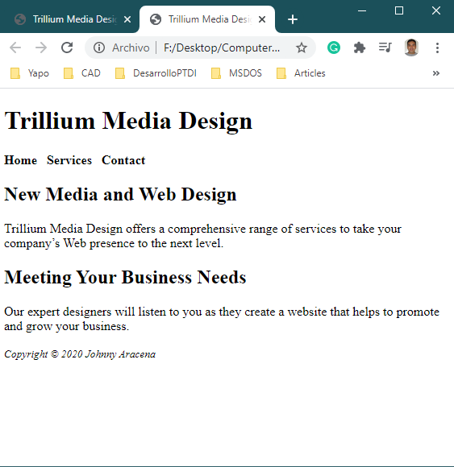

Hands-On Practice 2: Anchor Element

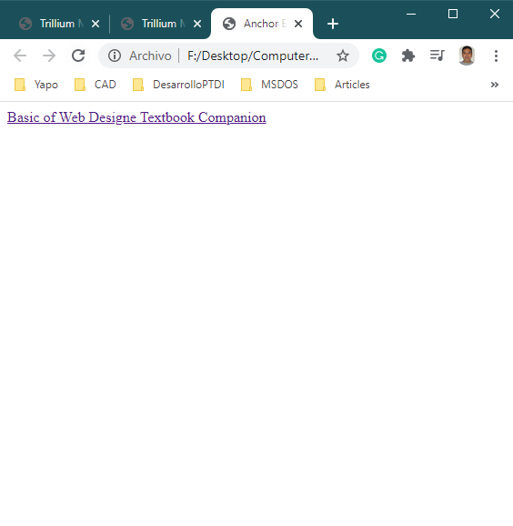

Hands-On Practice 3: Content Pages

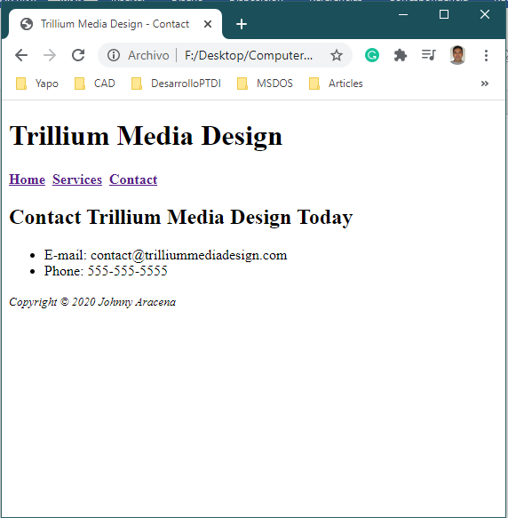

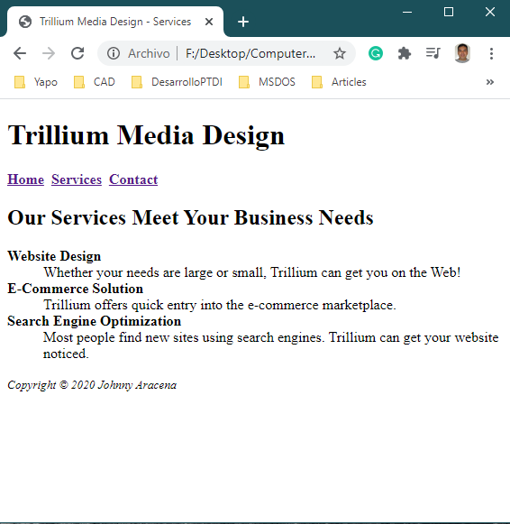

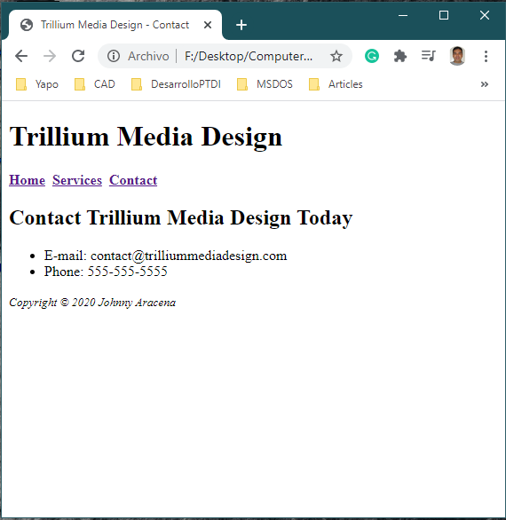

Hands-On Practice 4: E-Mail Hyperlinks

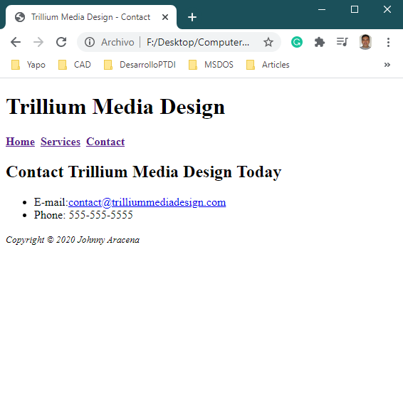

Hands-On Practice 5: HTML Syntax Validation

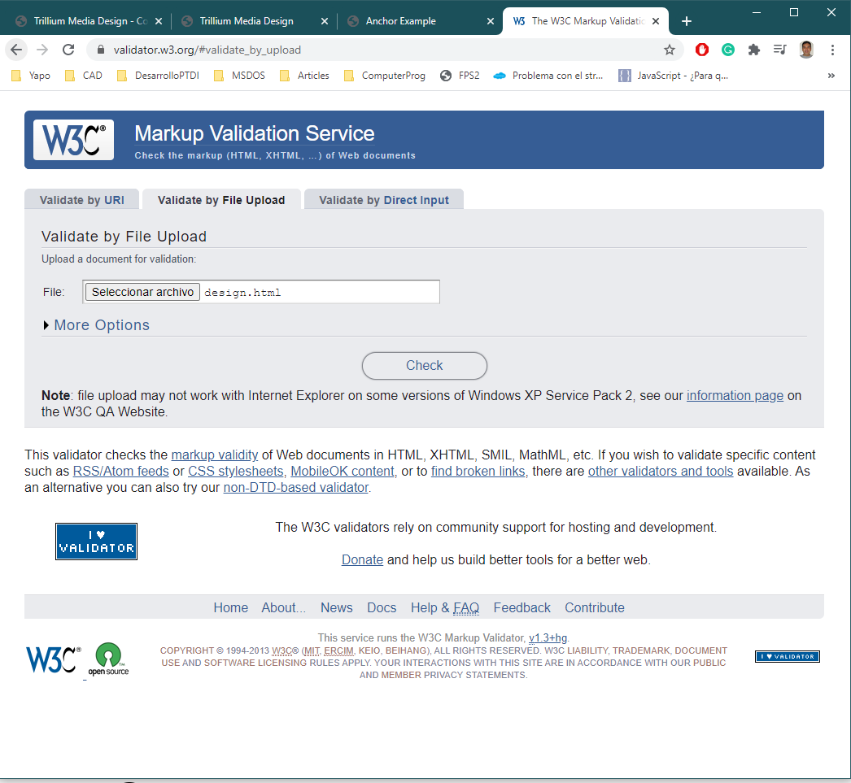

Show errors

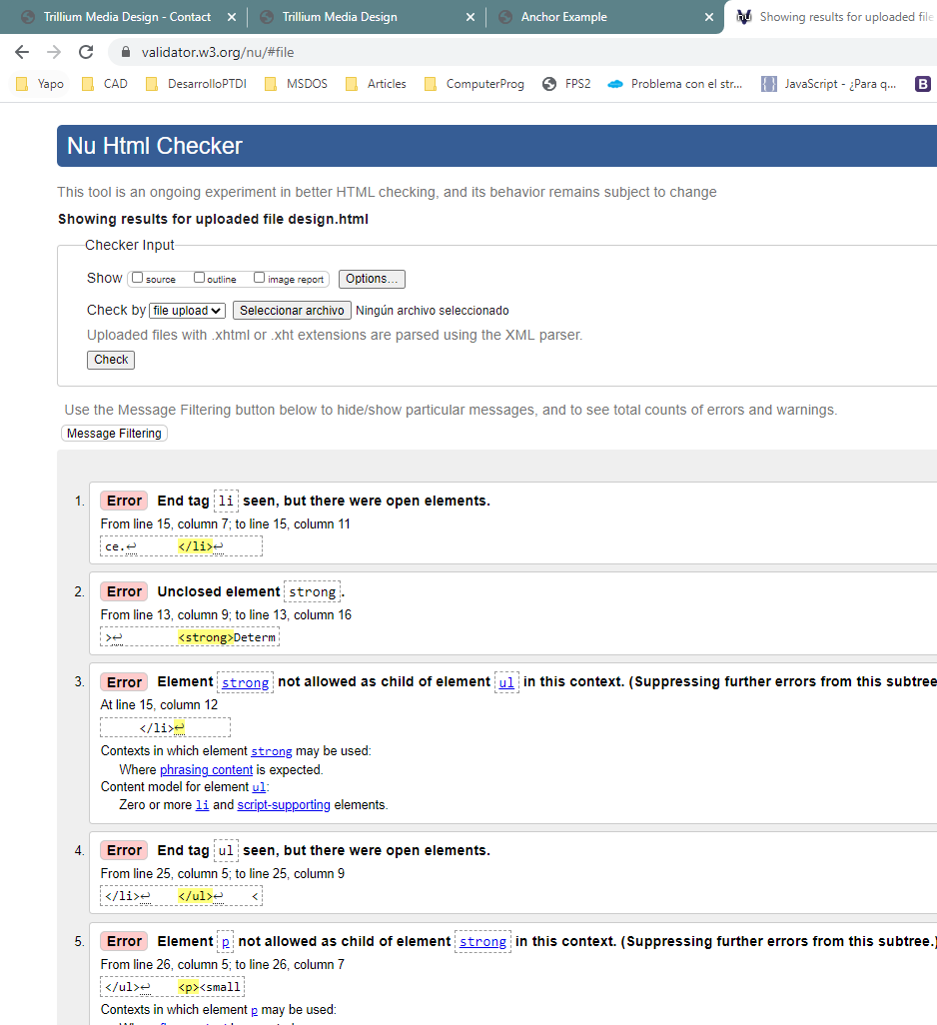

No errors

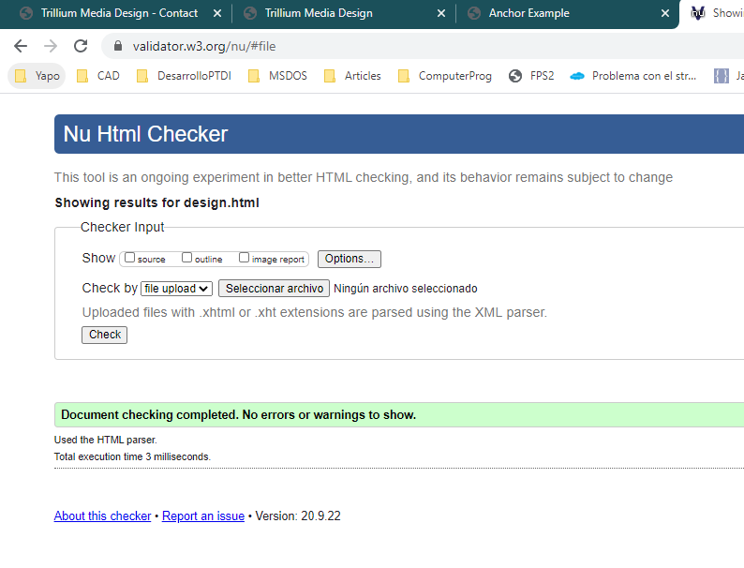

After-lab Assignment:

1. Create a one-paragraph conclusion of what you have learned during the lab today.

I learned today how a webpage is structured. I like how web page structure is divided and I learn how validate a web page too. Finally, I like very much how example web page works in interaction between links.

2. Markup language code alone does not make a web page—design is very important. Access the Internet/www and find two web pages—one that is appealing to you and one that is unappealing to you, and answer the following questions:

A. What is the URL of the website?

B. Is the page appealing or unappealing? List three reasons for your answer.

C. Would you encourage others to visit this site? Why or why not?

Unappealing web page

A: <http://www.cientificosaficionados.com/>

B: It web page is unappealing, because it has not a title, structure, color design, navigation menu, sections, some order, contact form and copyright

C: In relation to structure and design of web this page, I will not encourage others to visit this site, because it is poorly designed and structures it is an excellent example to know how not made a web page.

Appealing web page

A: <https://www.confederationcollege.ca/>

B: It web page is appealing. It has good structure, is consistent at its design It has good color selections, it has a sections, Its menu group topics related and provide several information in a good page distribution.

C: Yes, I recommend to someone visit its web page to have some idea about design, structure and information disposal. It is a good compare point to have some idea to build a new web page.